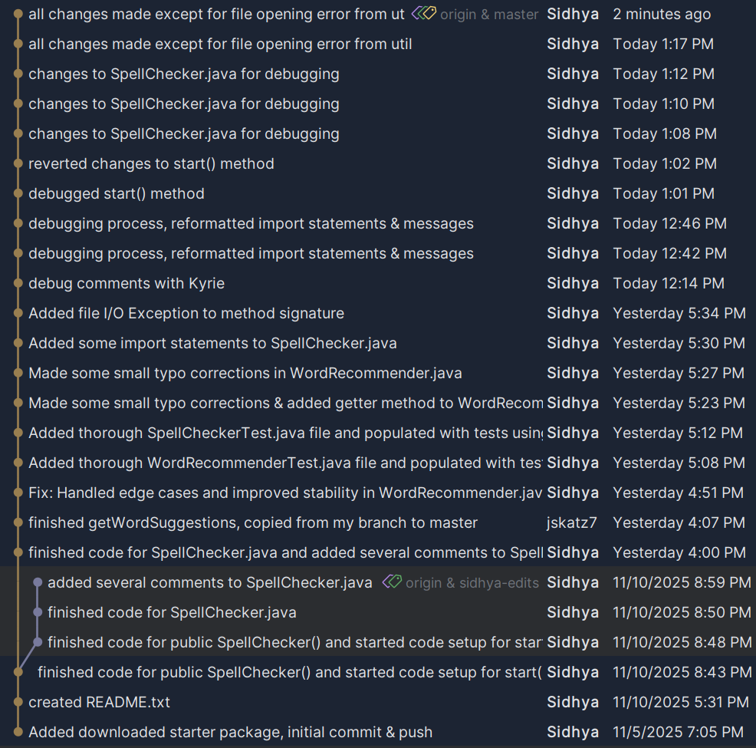
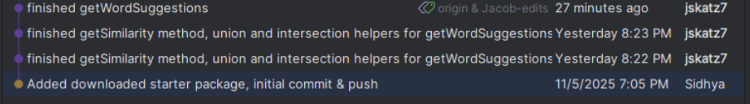
Both Sidhya & Jacob split the project workload evenly, Sidhya is just a chronic committer lol

